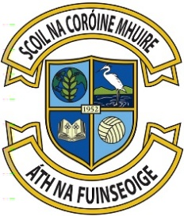

SCHOOL CALENDAR 2025-26

TERM 1

Re-open: Thursday 28th August 2025 for all classes except incoming Junior Infants
Friday 29th August Junior Infants in 9.45am – 12 noon
Mid-term: Monday 27th October to Friday 31st October Inclusive
Christmas Break: School closes Friday 19th December @ 12 noon
(Monday 22nd December – Friday 2nd January 2026 Inclusive)

TERM 2

Re-open: Monday 5th January 2026

Bank Holiday: Monday 2nd February 2026

Mid-Term: Thursday 19th and Friday 20th February 2026 (2 Days)

St Patrick’s Day Monday 16th and Tuesday 17th March 2026 (2 Days)
Easter break* School closes Friday 27th March @ 12 noon
(Monday 30th March – Friday 10th April Inclusive)

*School will close at 12 noon Friday 27th March 2026, which will be the final day of the school term, unless changes are required as part of contingency arrangements to make up for time lost due to unforeseen school closures. Where contingency arrangements are required a school authority may reduce the length of the Easter break.

TERM 3
Re-open: Monday 13th April 2026
May Bank Holiday: Closed Friday 1st and Monday 4th May 2026 (2 Days)
June Bank Holiday: Closed Monday 1st and Tuesday 2nd June 2026 (2 Days)
Summer holidays: School closes Thursday 25th June 2026 @ 12 noon

